ONLINE NOTES MANAGEMENT SYSTEM

# PROJECT REPORT

*Submitted in fulfilment for the J-Component of ITE1008 – Open Source Programming*

# CAL COURSE

***in***

**B.Tech. (Information Technology)**

*by*

**19BIT0023 Garvit Doda**

**19BIT0177 Rohin Srivastava**

*Under the guidance of*

## Prof. Jayakumar Sadhasivam SITE



**School of Information Technology and Engineering**

Winter Semester 2020-2021

**ABSTRACT**

Online Notes Manager is a web based software that helps its users to create text based notes that might be handy for others too. So the portal will enable the user to upload notes online for other users. Therefore, it also has a download option for the users.

The simplicity of the interface makes it easier to use and users can easily manage their notes or files online. Our efforts are to provide a web based application that helps users to create notes interactively. By using this platform, they can save their notes after creating and can also modify them whenever they want to.

**2**

**INTRODUCTION**

Now-a-days students don’t require a notebook to write down notes which are being taught in the class, as students are being taught in smart class through presentations prepared by their respective faculties. So, it is very difficult for the students to recall what they had studied in their classes and students had to bring storage devices to the classes to get the presentations or the notes. Therefore, taking this into consideration, we tried to make a web application which will help both students and teachers. It will provide the best means to circulate notes, presentations and files. Hassle free downloading, uploading and creating notes will make learning easier!

**3**

**PROBLEM STATEMENT**

Notes making is one of the handiest technique one uses while learning new things. Notes summarizes the gist of the subjects and are always useful for revisions. Whether the user is a student or a teacher, managing notes and circulating notes has been some of many the issues faced by many people. So students and teacher need a platform where they can easily create and share their material. Therefore, taking this into consideration, we tried to make a web application which will help both students and teachers. It will provide the best means to circulate notes, presentations and files. Hassle free downloading, uploading and creating notes will make learning easier!

**4**

**PROCESS FLOW DIAGRAM**

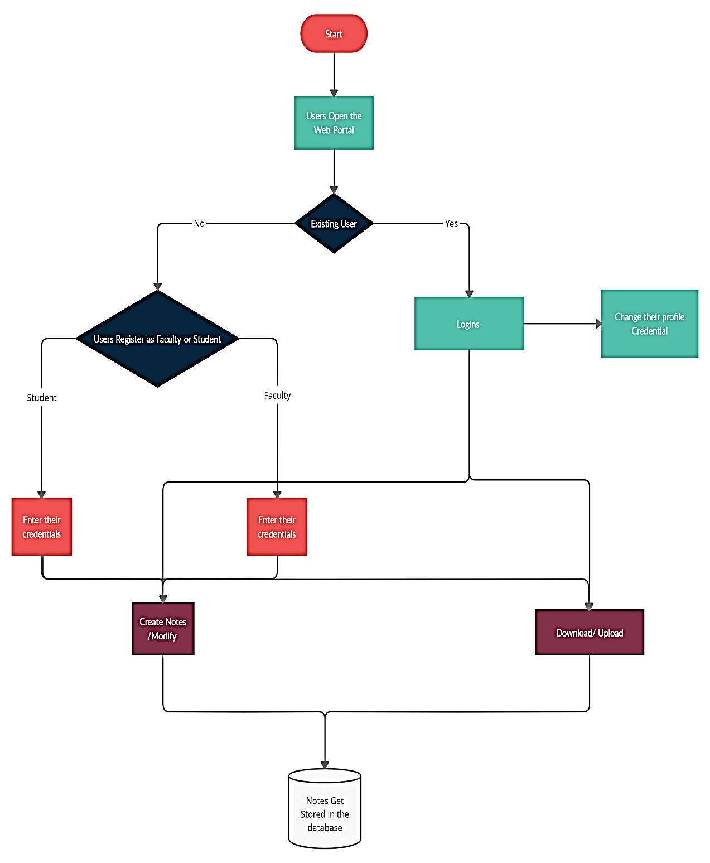

**4**

**MODULES**

**MODULE 1: USER SIGN IN/ LOGIN:**

In this module, if the user is opening the website for the first time has to sign in by giving his/her proper details, like username, name, password, gender, subject, and most imp type i.e., teacher or student. After sign in User can login into the site anytime he wants to just by giving his username and password. The details of the user get saved into the database.

**MODULE 2: CREATE NOTES:**

In this module, if the user wants to create notes on a particular topic then he or she can do it by using a text box provided in the website. They can save it using the save button. Later they can find it in the My Notes Section.

**MODULE 3: UPLOADS/ DOWNLOADS:**

In this module, if the user is a teacher then he/she can upload notes with a proper title and a short description about the note so that it will be easy for the student to find it. Teachers can upload note only in their subject section like a computer science teacher can uploads notes only in computer science section and same goes with the other domains. The file format can be a ‘pdf’, ’doc’, ’ppt’, ’txt’, ’zip’ and a max size of 30 MB. Teachers can also see other teacher’s profile and the notes uploaded by them. If the user is a student, then he/she can download their respective domain teacher’s notes, and can also view their profile.

**MODULE 4: PROFILE EDITING:**

In this module, a user can edit their profile details, like Username, Name, Phone number, E-mail id, also their Profile picture. It also has a feature of forgot password, if a user forgot the password then just the user has to type their registered E-mail id and a code will be sent to their e-mails and then the user is able to change their password.

**5**

**ENTITY RELATIONSHIP DIAGRAM**

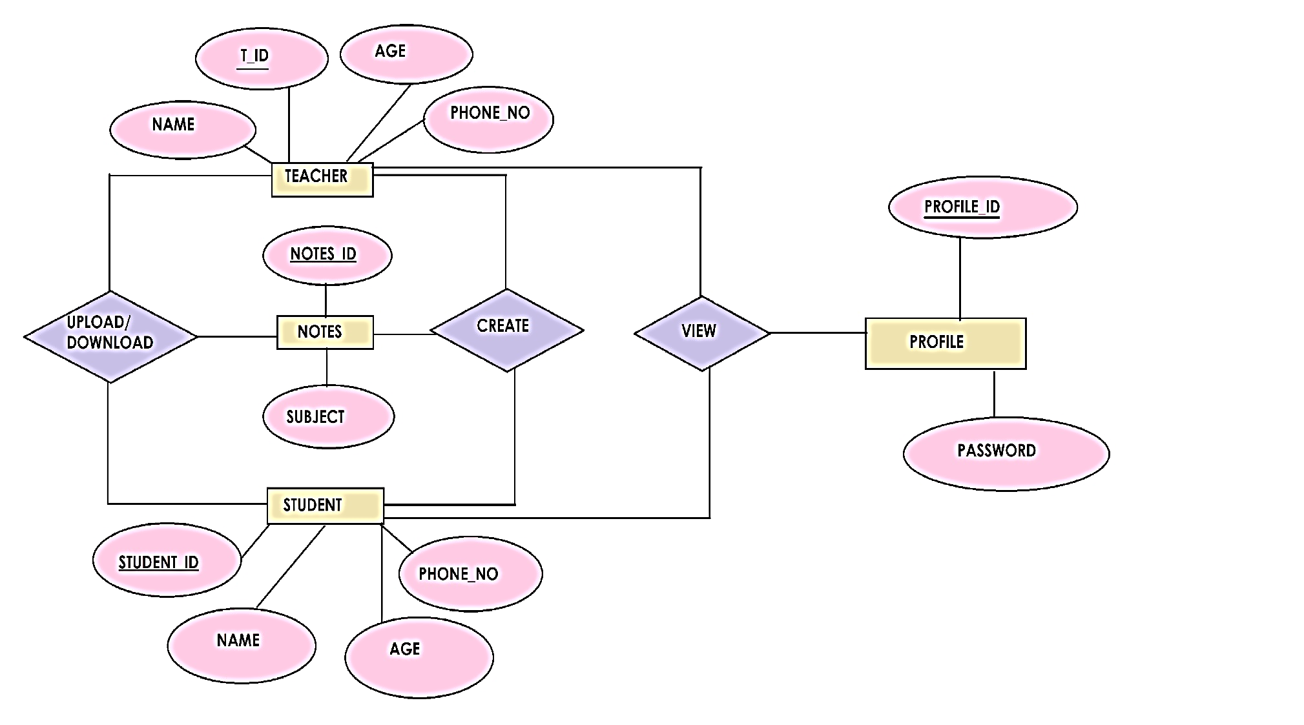

**6**

**DATABASE DESIGN**

**TABLES IN OUR DATABASE**

* Registration(username(pk),email,password,types);
* Notes (notes_id(pk),subject,types)
* Saved Notes(notes_id(pk),subject,types)

**7**

**CONCLUSION**

This concludes the Note Taking module.  In this module, we incorporated effective strategies for students to take notes during class lectures.  Effective note taking is an important academic activity that helps you concentrate, stimulates your ability to recall, and helps you the be organized. With increase in online work students prefer taking down notes digitally over writing them down. As the notes can be kept safe without any physical damage to them. Uploading and Downloading them hassle free, will be a boon to them. In addition to this Creation of Notes and saving them online on the server helps them to be more organized.

With this portal or system students can easily have their notes organised online. Thus we find our project capable of providing the functionalities the students need.

**8**

**REFERENCES**

**General Internet Site –**

[1] GeeksForGeeks –

<https://www.geeksforgeeks.org/how-to-create-text-editor-using-javascript-and-html-dom/>

[2] W3Schools –

<https://www.w3schools.com/php/php_file_create.asp>

[3] StackOverflow –

<https://stackoverflow.com/>

**9**

**SNAPSHOTS**

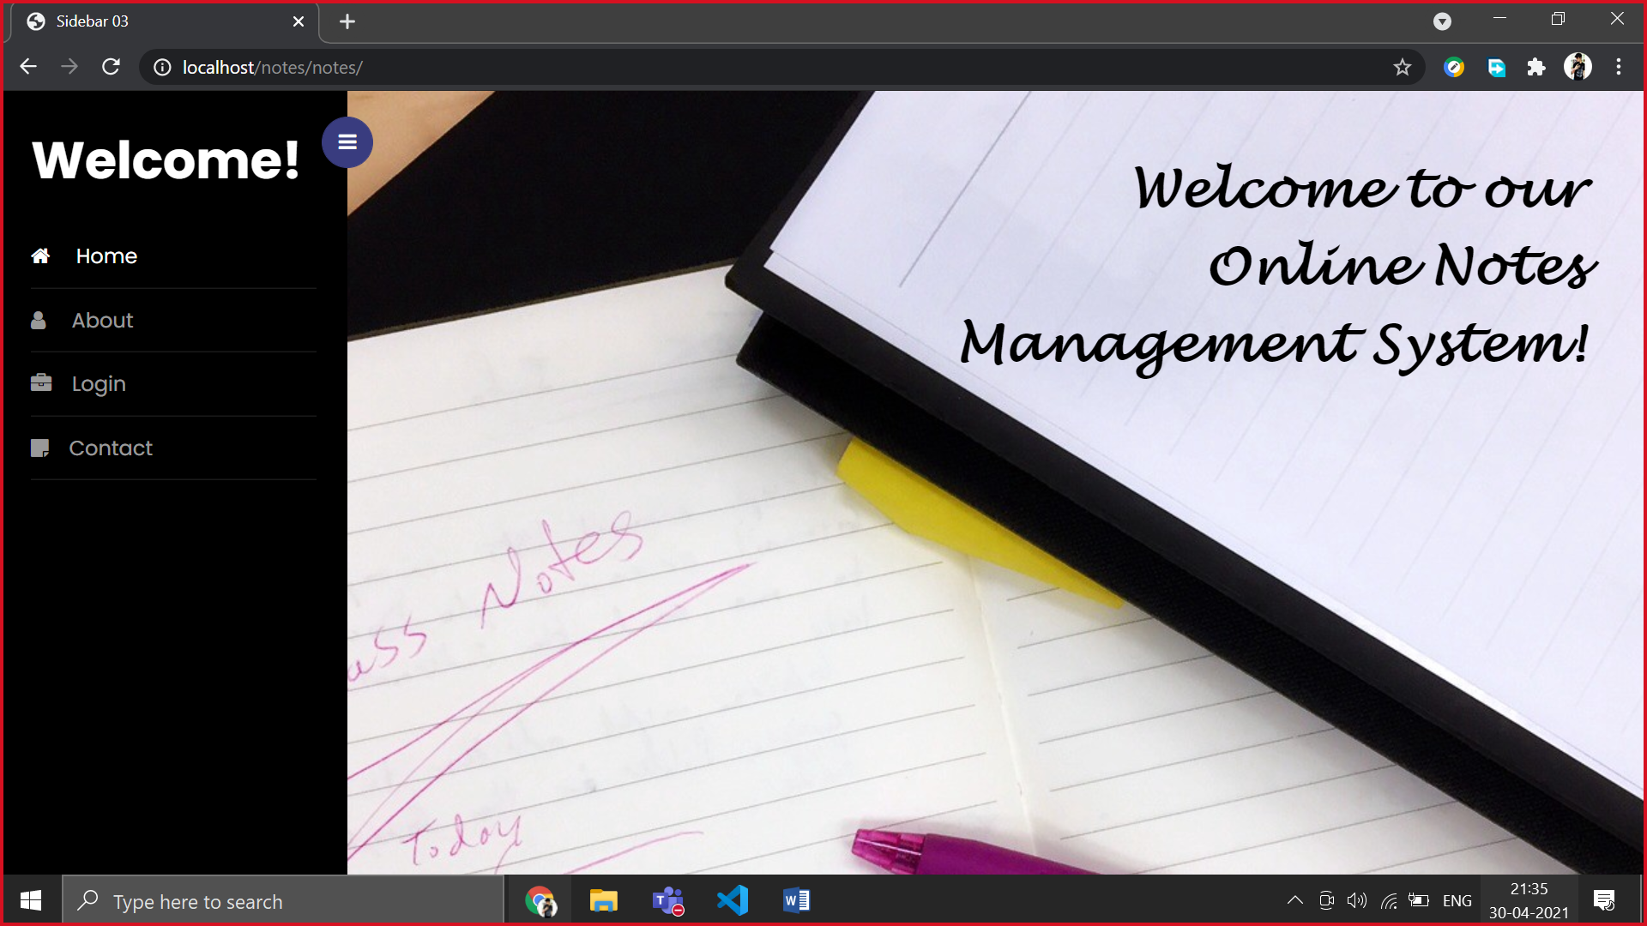

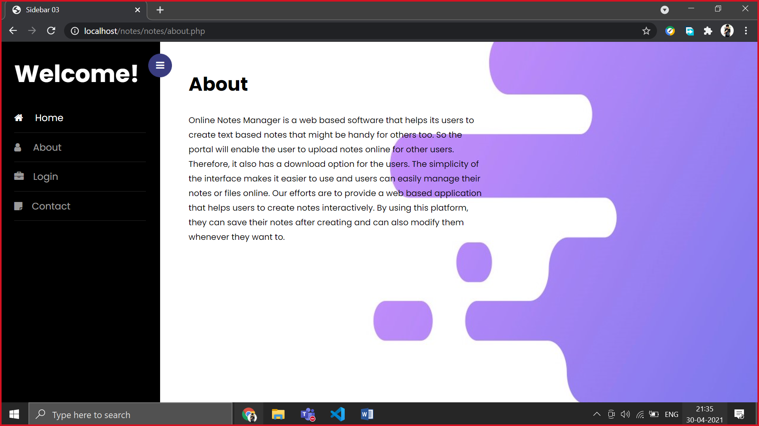

**10**

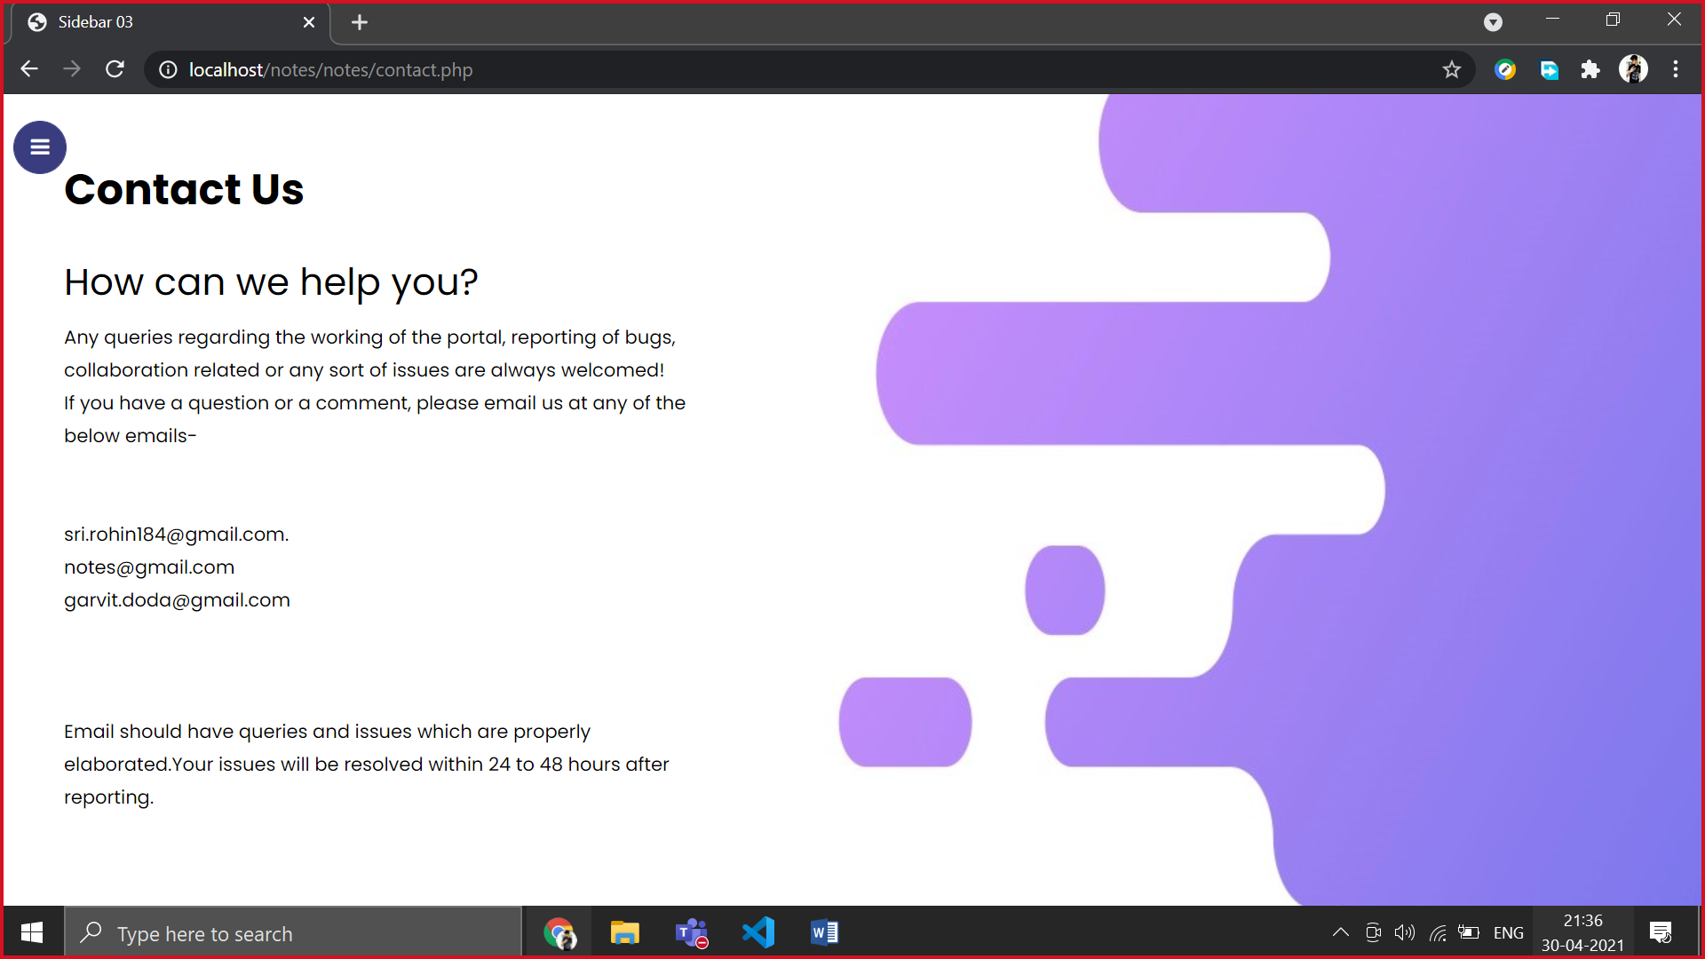

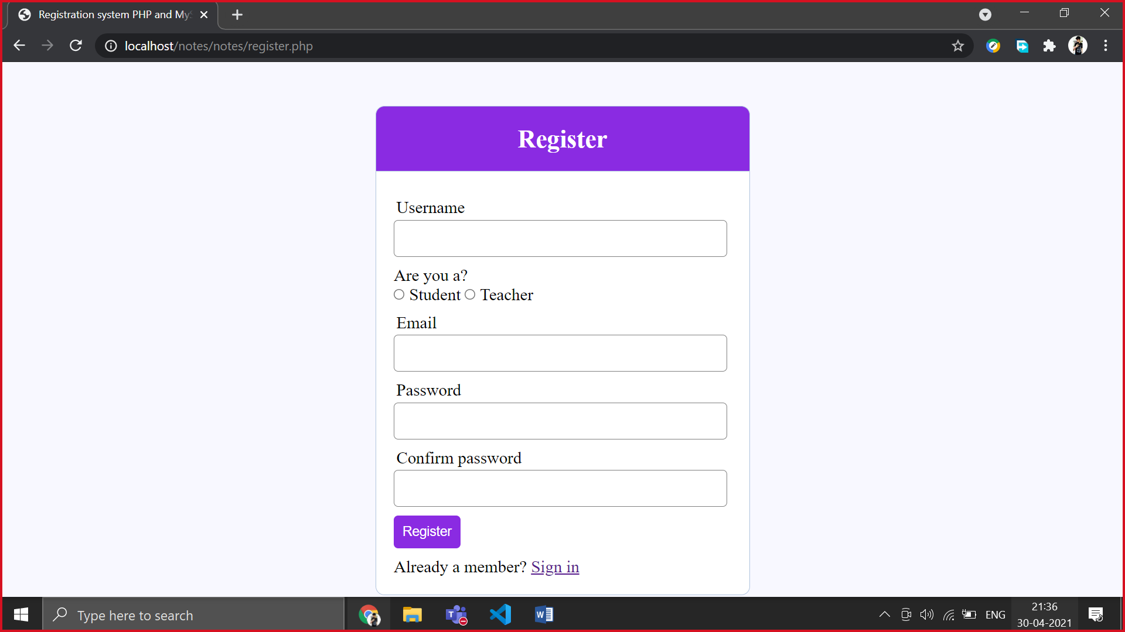

**11**

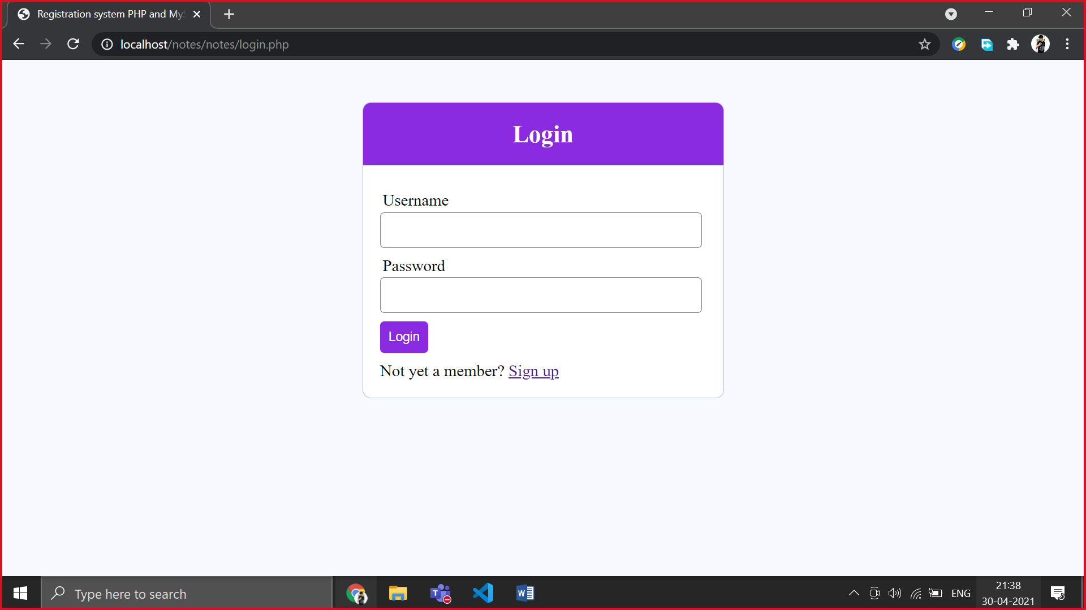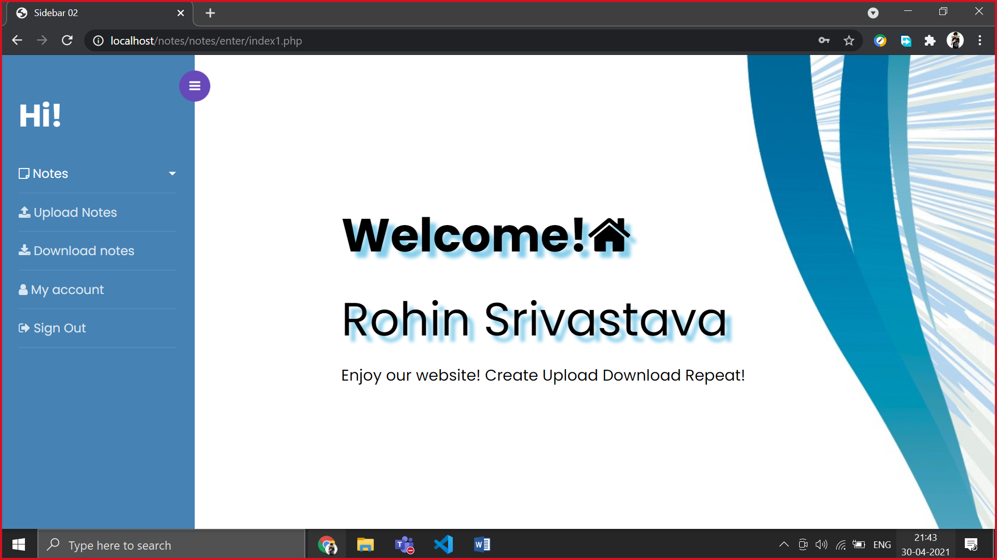

**12**

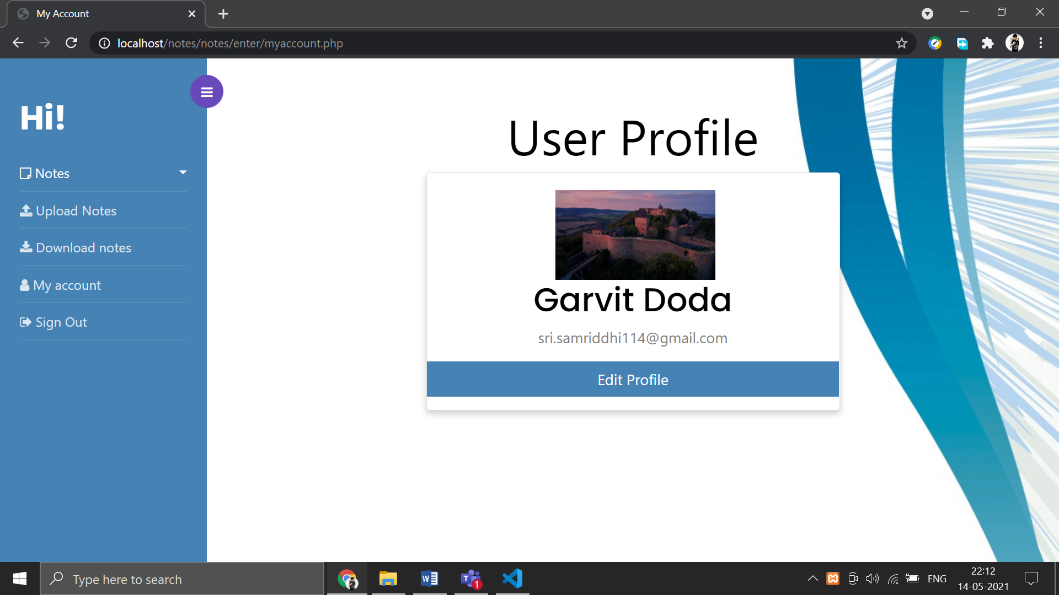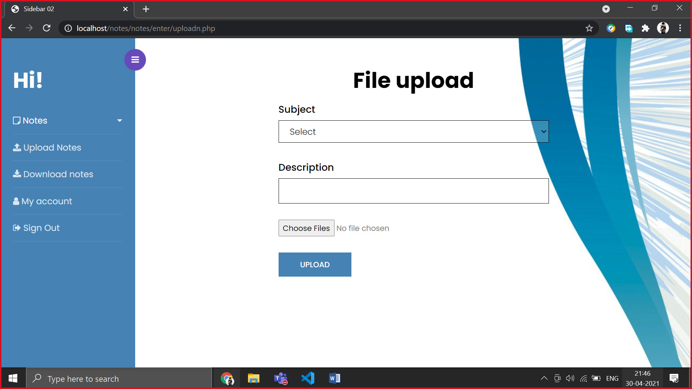

**13**

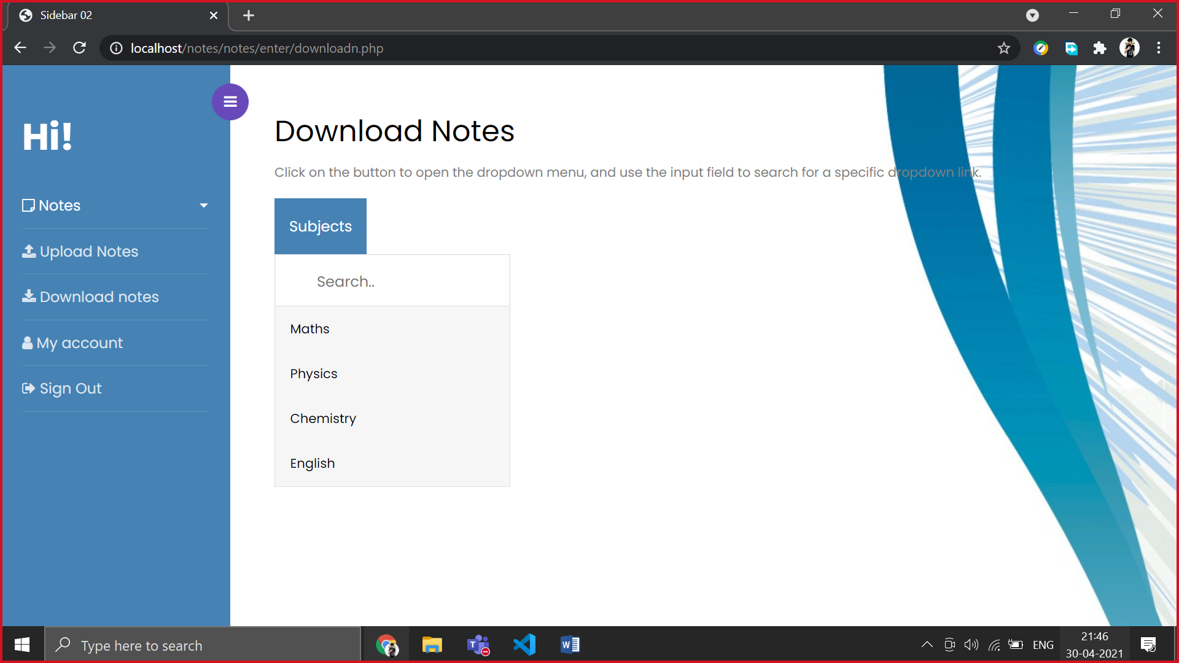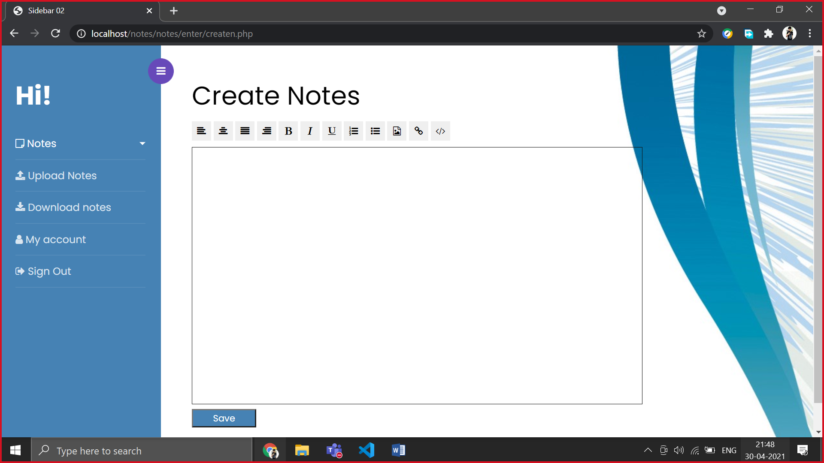

**14**

**SOURCE CODE**

**INDEX.PHP**

<!doctype html>

<html lang="en">

  <head>

    <title>Online Notes Management System</title>

    <meta charset="utf-8">

    <meta name="viewport" content="width=device-width, initial-scale=1, shrink-to-fit=no">

    <link href="https://fonts.googleapis.com/css?family=Poppins:300,400,500,600,700,800,900" rel="stylesheet">

    <link rel="stylesheet" href="https://stackpath.bootstrapcdn.com/font-awesome/4.7.0/css/font-awesome.min.css">

    <link rel="stylesheet" href="css/style.css">

  </head>

  <body style="background-image:url('back3.jpeg');">

    <div class="wrapper d-flex align-items-stretch">

    <?php include('navigation.php')?>

      <div id="content" class="p-4 p-md-5 pt-5">

        <h2 class="mb-4" style="text-align:right; font-family:'Lucida Handwriting';font-size:40px"><b>Welcome to our <br>Online Notes<br>

     Management System!</b></h2>

      </div>

    </div>

    <script src="js/jquery.min.js"></script>

    <script src="js/popper.js"></script>

    <script src="js/bootstrap.min.js"></script>

    <script src="js/main.js"></script>

  </body>

</html>

**15**

**SERVER.PHP**

<?php

session_start();

$username = "";

$email    = "";

$errors = array();

// connect to the database

$db = mysqli_connect('localhost', 'root', '', 'notes');

mysqli_query($db, "CREATE table Reg (username VARCHAR(50), email VARCHAR(50),password VARCHAR(50), types varchar(50),picture varchar(255))");

mysqli_query($db, "CREATE table upload (file_id INT(20) NOT NULL AUTO_INCREMENT,file_name varchar(30), file_uploaded_by varchar(40), file_uploaded_on date,subject VARCHAR(50), description VARCHAR(500), types varchar(50),path varchar(500), PRIMARY KEY (file_id))" );

mysqli_query($db, "CREATE table mynote(file_name VARCHAR(50), file_uploaded_by VARCHAR(50))" );

// REGISTER USER

if (isset($_POST['reg_user'])) {

  // receive all input values from the form

  $username = mysqli_real_escape_string($db, $_POST['username']);

  $email = mysqli_real_escape_string($db, $_POST['email']);

  $password_1 = mysqli_real_escape_string($db, $_POST['password_1']);

  $password_2 = mysqli_real_escape_string($db, $_POST['password_2']);

  $types= mysqli_real_escape_string($db, $_POST['type']);

  // form validation: ensure that the form is correctly filled ...

  if (empty($username)) { array_push($errors, "Username is required"); }

  if (empty($email)) { array_push($errors, "Email is required"); }

  if (empty($password_1)) { array_push($errors, "Password is required"); }

  if ($password_1 != $password_2) {

  array_push($errors, "The two passwords do not match");

  }

  // first check the database to make sure

  // a user does not already exist with the same username and/or email

  $user_check_query = "SELECT * FROM reg WHERE username='$username' OR email='$email' LIMIT 1";

  $result = mysqli_query($db, $user_check_query);

  $user = mysqli_fetch_assoc($result);

  if ($user) { // if user exists

    if ($user['username'] === $username) {

      array_push($errors, "Username already exists");

    }

    if ($user['email'] === $email) {

      array_push($errors, "email already exists");

    }

  }

  // Finally, register user if there are no errors in the form

  if (count($errors) == 0) {

    $password = $password_1;

    $query = "INSERT INTO reg (username, email, password, types, picture)

          VALUES('$username', '$email', '$password','$types','../I1/usericon.jpg')";

    mysqli_query($db, $query);

    $_SESSION['username'] = $username;

    $_SESSION['success'] = "You are now logged in";

    header('location: enter\index1.php');

  }

}

  if (isset($_POST['login_user'])) {

  $username = mysqli_real_escape_string($db, $_POST['username']);

  $password = mysqli_real_escape_string($db, $_POST['password']);

  if (empty($username)) {

    array_push($errors, "Username is required");

  }

  if (empty($password)) {

    array_push($errors, "Password is required");

  }

  if (count($errors) == 0) {

    $password = $password;

    $query = "SELECT * FROM reg WHERE username='$username' AND password='$password'";

    $results = mysqli_query($db, $query);

    echo $password.$username.mysqli_num_rows($results) ;

    if (mysqli_num_rows($results) == 1) {

      $_SESSION['username'] = $username;

      $_SESSION['types'] = $types;

      $_SESSION['email'] = $email;

      $_SESSION['success'] = "You are now logged in";

      header('location: enter\index1.php');

    }else {

      array_push($errors, "Wrong username/password combination");

    }

  }

}

?>

**17**